Saturday, June 9th is

Relief Through Rolling Day!
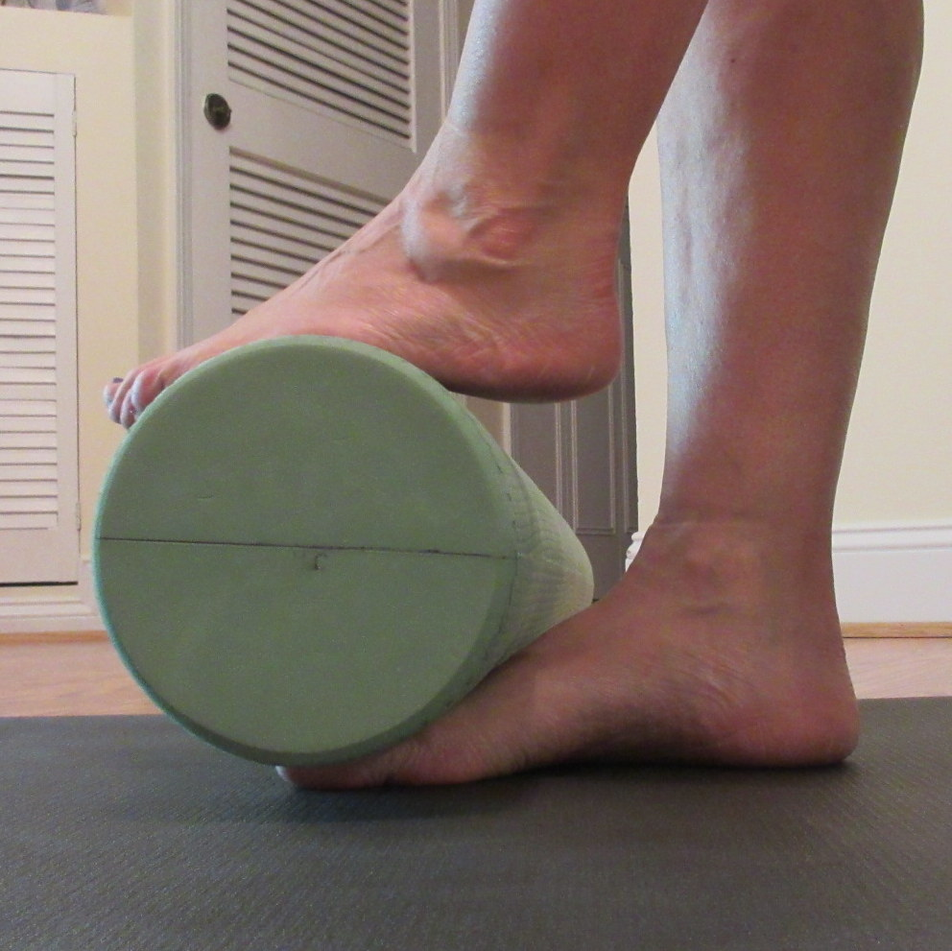
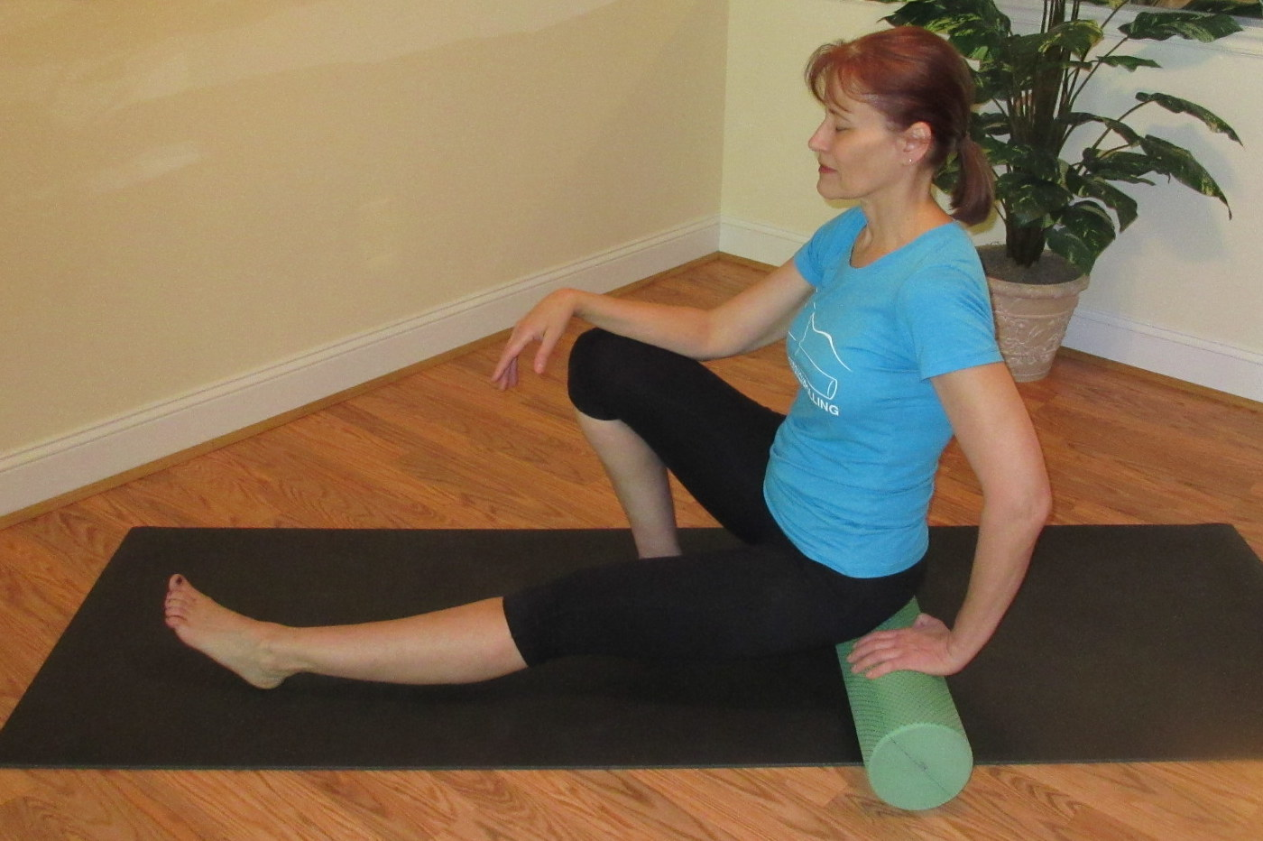
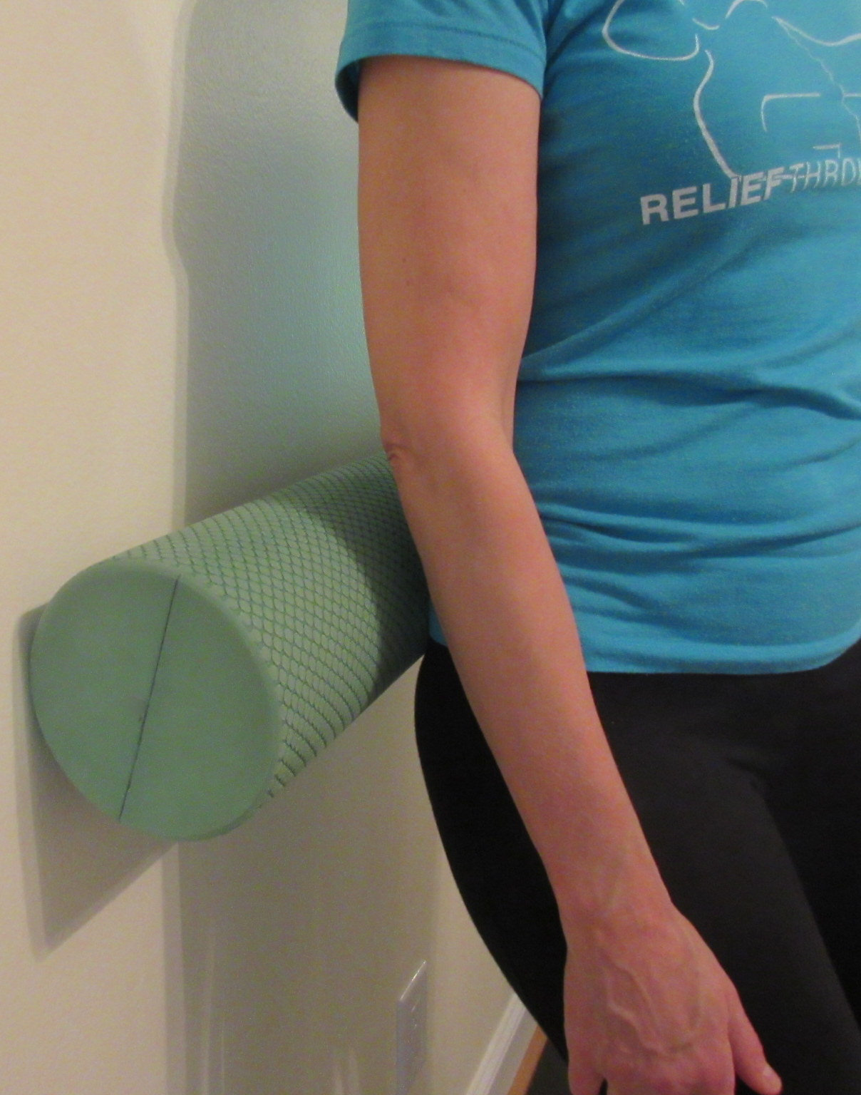

  - Pain is the Epidemic!
  - Pain is a global health problem.
  - • 1 in 10 people globally have chronic pain.
  - • 25M American adults report daily pain.
  - • Economic costs in United States $635B (Get the Facts, 2014).

  - —
  - Learn this simple, research supported program for At-Home Relief for any type of pain.
  - —

  - Private 1 Hour Relief Through Rolling Session
  - Save $15 on Saturday, June 9th, 2018
  - Only $75
  - (One offer per person.)
  - Sessions may also be scheduled at your convenience during typical business hours at the regular fee.
—
So simple, that anyone of any activity level can participate. You owe it to yourself to try it. And, please, tell a friend.

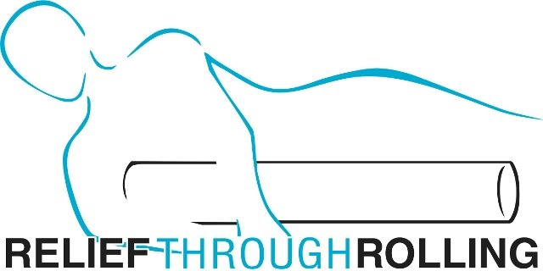

Janet Herman, LMT, Pro-Certified RT Rolling Instructor RTROLLING.COM/janetherman GetReliefThroughRolling@gmail.com 404-422-4899

