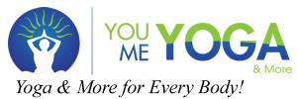

PRESENTS
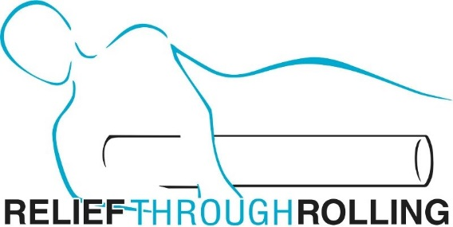
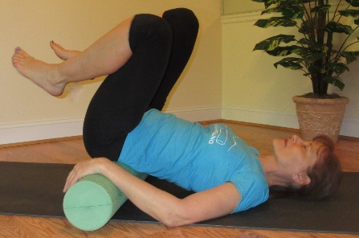

A Simple and Pain-Free Foam Rolling Program…For Everyone!

“HIP, HIP--RELIEF!”
Join Janet Herman, LMT for the opportunity to learn simple and effective techniques to increase mobility in the pelvis, hips, low back, and legs. Learn how to give yourself quick relief from hip and low back pain related to arthritis, bursitis, sciatica, and more, as well as reduce tension and discomfort in the hamstrings and entire leg region. Learn key application principles that bring quick, effective and lasting results. Experience changes in your entire body, reduce the chance for injury, and have more efficient and effective posture and movement. The Relief Through Rolling program for this key region improves posture, flexibility balance and function of your entire body and is suitable for people of all activity levels.
Saturday, November 10, 2018
2:00 – 4:00pm
$30 Advance/$35 after November 3
Register at YOU YOGA, ME YOGA 404-654-3336
Bring your 36 x 6 inch foam roller to class.
To borrow a roller for class, register today with your request to reserve one, as a limited number are available.

FOR MORE INFORMATION

Janet Herman, LMT 404-422-4899 GetReliefThroughRolling@gmail.com JanetHerman.MassageTherapy.com/Relief-Through-Rolling
At Home Programs Available

